GRST Programming Challenge Aggregator

Report 2 – final integrated version

Prepared by: Matthew Griffin, Ashish Rastogi, Kiritbhai Soheliya, Martin Tiernan, Brenton Dube

Software Engineering, Fort Hays State University

https://github.com/mgriffin3/GRSTInteraction Diagrams

Table of Contents

Interaction Diagrams 3

Front-end Class Diagram 7

System Architecture and System Design 10

Data and Algorithms………………….. 13

User Interface Design and Implementation 15

Design of Tests – Front-end Tests 16

Design of Tests – Back-end Tests.. 18

Project Management and Plan of Work 19

* + - Matthew Griffin: Project Management Section, System Architecture and System Design parts c-g,
    - Martin Tiernan: Front end Class Diagrams, Architectural Styles, Identifying subsystems
    - Brenton Dube: User Interface Design and Implementation. Edited together multiple documents containing portions of the contributions to this report into the final version. Edited final Table of Contents. Added reported contributions.
    - Ashish Rastogi: Webpages for the website. (Home Page, User sign-up, User login, User profile page, Challenge Search Functionality, Challenge view page)
    - Kirit Soheliya: mySQL database structure design. Populate Database table with dummy data. Tested basic functionality.
    - Everyone: Multiple hours of group discussion, which contributed to this report.

Interaction Diagrams

We focused on a main set of four use cases that represent the core of the program search, view, fetch, and store. This encompasses the basic functions of both our programs front and back ends. It is important that this core is well designed and understood before any future features can be added. The focus of this report will be on a “Guest” user since a registered user is expanded upon a guest user experience we can’t implement those features without this base.

**Use Case 1: Search**

The first and primary use of the application is searching the site. This will be used by both “guest” users and registered users. This begins at the interface which then sends the users requests through all the necessary subsystems. This is similar to Use Case two but has slightly more interaction since it can return a blank result.

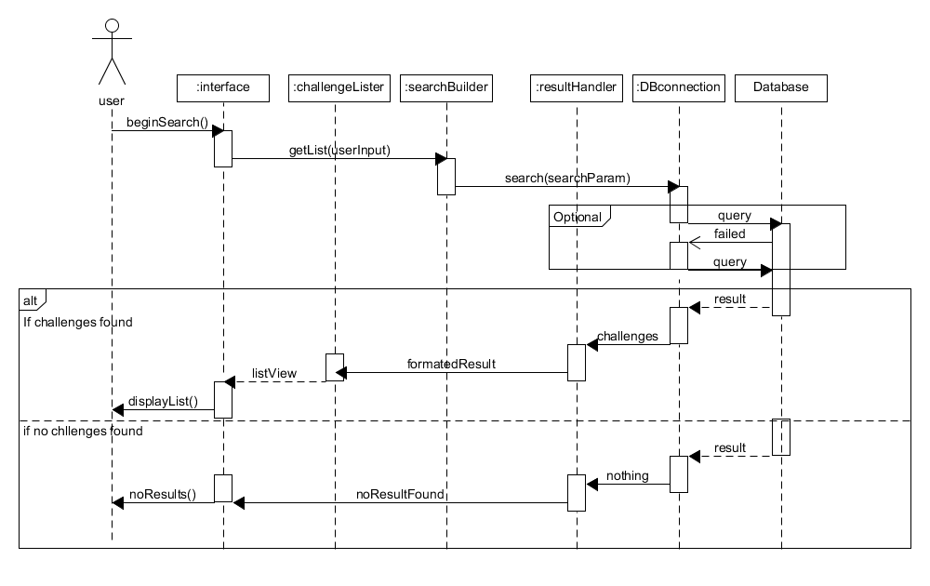

**High cohesion principle**: The user requests a search which is passed on to the search builder which represents the high cohesion principle. The interface only handles the interaction between the user and sends requests to other objects to fulfil the request. Also challenge lister is only responsible for creating a list page, if no results are found there is no reason for it to be called. Additionally, separating the result and the challengeLister and resultHandler a change in the format in the database when not affect the creation of a list. Creating high cohesion.

**Expert Doer principle:** By having the DBconnection be the only person that interacts with the database it allows for the other subsystems to not car about how to access the actual database. DBconnection is the only part that accesses in both the front and back ends.

**Use Case 2: View**

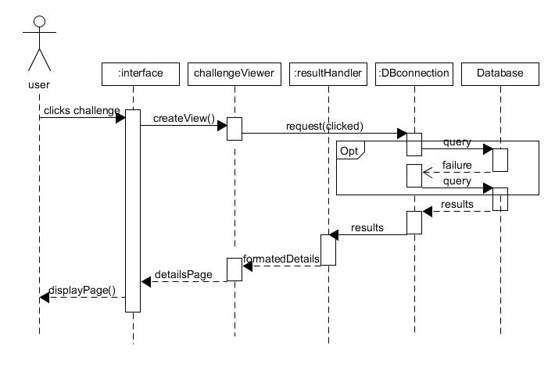 The second most important thing is for users to be able to access the details of the challenges. The interface yet again sends the request through various subsystems. It is important to note that in both use cases that the interface doesn’t manipulate or handle the data directly, but simply interacts with the user presenting the elements created by the system. Since we know that a challenge is stored with details, we know there will not be a case of a blank query, unless there is database malfunction. This is the primary difference between use case one and 2.

**High Cohesion Principle:** When a user clicks on the challenge the interface does request to build the challenge view. By separating the creation and the displaying the application becomes more cohesive.

**Expert Doer Principle:** The results handler handles results from the database no matter what it is since it already knows how to handle challenge input there is no reason to creating another subsystem to handle data from the database.

**Use case 7: Fetch**

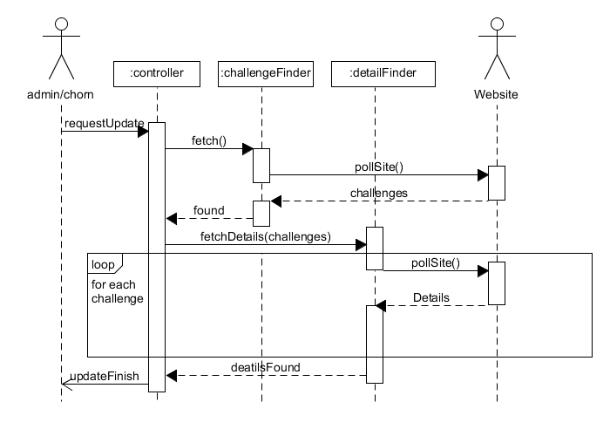 Use case 7 and 8 use to be a single use case, but they are both independent enough to be separated. This begins with a request from the system or an admin and then the controller takes over. The controller requests both the challengeFinder and the DetailFinder to scrape the data from the specified website.

**High Cohesion Principle**: Separating the challenge finder and detail finderallows for formatting for two different types of data the location of challenges and the details of the challenge they can be manipulated as needed since they are two very different pieces of data. The controller doesn’t actually manipulate data, but rather control timing and pass messages along to other subsystems.

**Use Case 8: Store**

This case will be automatically called by the system when there is information in finder classes to store. It will then began formatting the data in the inserter objects and the pass it to DB connection to store within the database.

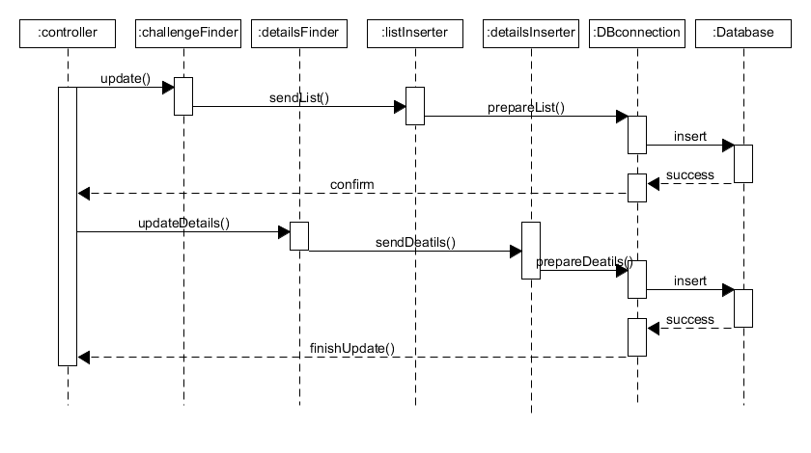**High Cohesion Principle:** By separating the Challenge locations and the details of those challenges we can format them appropriately without having one big formatting class. This is shown in the separation of detailsInserter and detailsInserter.

**Expert Doer Principle**: Again here we see that DBconnection is the one source that interacts with the database. This makes easy to change interactions with the database since it is all contained within one subsystem.

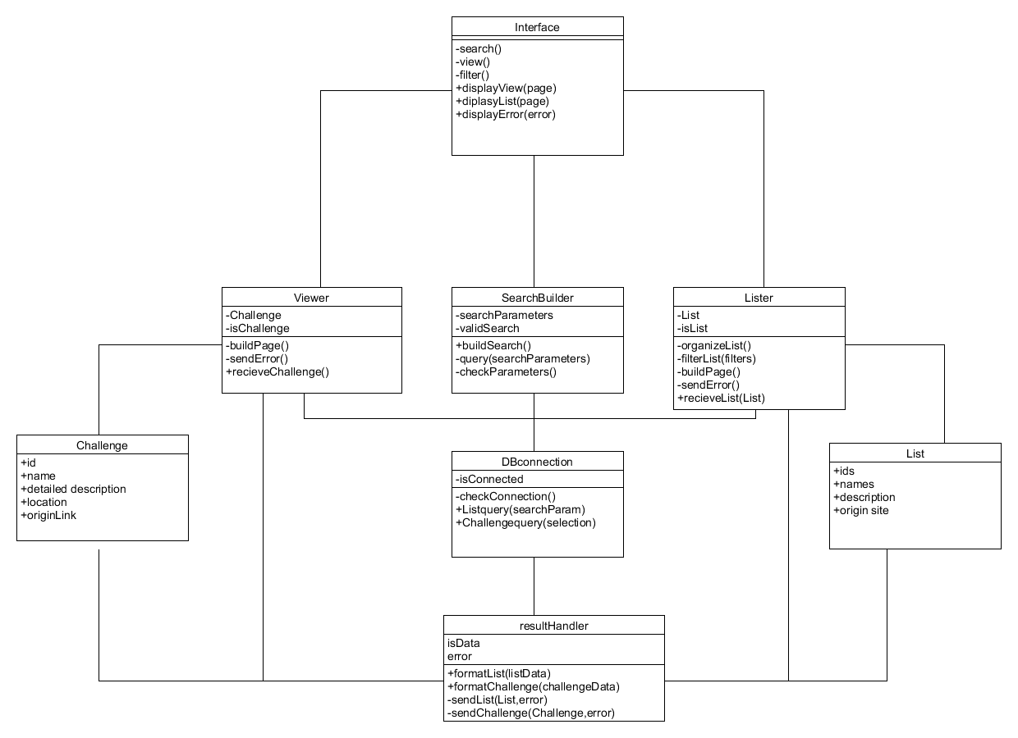Front-end Class Diagram

Front-end data and operator types

**Interface:**

Operations

1. -search(): trigger an html event that calls to SearchBuilder and passes html forum information
2. -view(): trigger an html event that calls the Viewer and passes challengeID
3. -filter(): calls lister to filter
4. DisplayView(page): displays new html page received from viewer
5. DisplayList(page): displays a new list that is returned from Lister
6. DisplayError(error): displays error message based on type

**Viewer:**

Attributes:

1. -Selection: a challenge datatype
2. -isChallenge: bool to check if it has an actual challenge

Operations:

* -buildPage(): build html from Challenge info and call interface to display
* -sendError(): error detected when trying to create page
* +recieveChallenge(challenge): receive a challenge data, assign to selection and begin calling either buildPage or sendError

**SearchBuilder**:

Attributes:

* -searchParameters: String
* -validSearch: Bool

Operations

* +buildSearch(): creates search parameters based on passed forum information
* -query(searchParameters): send a search to db connection
* -checkParameters(): check to see if valid parameters or return error.

**Lister**:

Attributes:

* +CurrentList: List datatype
* -isList: bool

Operations:

* -organizeList(): sort and organize list for the optimal viewing
* -FilterLIst(filters): filter List based on filters
* -buildPage(): build html page and call the interface to display
* -sendError(): send error to interface
* +recieveList(list): assing list as currentList and call buildPage() or sendError()

**Challenge**

Attributes:

* +id: int
* +name: string
* +detailedDes string
* +originSite string
* +originLink string

**DBconnection**

Attributes:

* -isConnected bool

Operations:

* -checkConnection(): check to see if there is a response from database
* +listQuery(searchParam): called by searchBuilder query database and then calls resulthandler
* +viewQuery(selection): called by viewer returns data to resulthandler

**List**

Attributes:

* +ids: int array
* +names: string array
* +shrotDes: string array
* +orignSites: string array

**resultHandler**

Attributes:

* isData : bool
* error: int

Operations:

* +formatList(ListData): turns database data into List data structure
* +formatChallenge(challengeData): turns database data into Challenge data structure
* -sendList(list,error): send a List to listbuilder and include any errors that occurred
* -sendChallenge(challenge,error): send a Challenge to viewer and include any errors that occurred

System Architecture and System Design

**Architectural styles**

The most benefiting style for are system would be a multitiered architecture. Specifically, a three-tiered architecture. In this style we can separate all the components into three main systems, presentation logic and application. This is the classical design for web-based apps and websites, so it is the most fitting for our programming solution. In this style the presentation front-end is responsible for showing user the data that the logical application layer calculated or retrieved from the data tier.

This benefits us the must because it allows us to format the data as needed, as we are pulling from multiple sites. It is beneficial to have the database separate in these layers we only need to make changes in one subsystem to accommodate the change, as opposed to more centralized styles which would be more work to adapt and accommodate multiple sites.

**Identifying Subsystems**

**Presentation/Interface:**

The first subsystem that is present within is the presentation. This contains both our user interface and our back-end controller, this subsystem is responsible for requesting the builder subsystem to retrieve/store data and present the users with the outputted data. This subsystem doesn’t care about what or how retrieved data was handled, calculated or stored.

**Application/Worker:**

Are worker subsystem being what creates data to display to user. This includes are finders, and builder classes. This layer is both responsible for bridging the users with the database. It both formats for display and storage. There should be no direct interaction with the database here. It only manipulates data that has been acquired already. If a change to the database should occur this subsystem should mostly be unaffected.

**Data/Database:**

The third and final subsystem is the database. This also includes inserters and the result handler classes. In this stage the defining feature is if we were to change the database system would the classes need to be changed. Only classes that have direct interaction with the database here.

**Mapping Subsystems to Hardware**

Our system will run from two locations: the user’s computer and a server. The server will contain our database, web scraper, and the parts of our front-end that connect to the database. The actual user interface will be run client-side as a web

**Persistent Data Storage**

We are using a relational database for persistent storage. The database will contain all collected information about challenges and will also store user account information.

The DESC of the challenge table will look like:

|  |  |  |  |  |  |
| --- | --- | --- | --- | --- | --- |
| id | int(11) | NO | PRI | *NULL* | auto_increment |
| name | text | NO |  | *NULL* |  |
| text | text | NO |  | *NULL* |  |
| origin | text | NO |  | *NULL* |  |
| difficulty | text | NO |  | *NULL* |  |
| url | text | NO |  | *NULL* |  |

User accounts are not being implemented until demo 2. Tentatively, there will be a user accounts table with user id and user name. Each account will get a custom table for keeping track of favorite challenges and status changes. This may change based on security or sprred/size concerns.

**Network Protocol**

Our systems will use HTTPS.

**Global Control Flow**

Our system is partailly procedure and partially event driven. Our back-end is procedure driven. The only option for the back end is whether or not to get challenges from a given site – everything else is automatic. The front end is event-driven. It does nothing until the user tells the system to search. Once a list of challenges has been returned, they can either modify the search and search again or select any returned challenge to view more information. Our system uses no timers, has no time dependency or requirements, and only uses single threads.

**Hardware Requirements**

Our back-end and database will require a server with a high-speed internet connection. The front-end will require a computer, a monitor, a contemporary web-browser and a high-speed internet connection. Our system is not resource intensive; any computer capable of running the current version of firefox should have no issues.

Data and Algorithms

FRONT END:

Fortunately, are system doesn’t use many complex data structures. Since we store the data in an SQL database. We can retrieve the data from the database and store it in simple container objects which we then use to generate the display for the user. Also, since the front end is primarily responsible for interacting with the user the complexity of the algorithms is low. Most of the functions involve storing and retrieving text-based data which is a common and well-known type of system.

Back End:

The backend also does not use any complex algorithms, but it uses lists and queues. As discussed earlier, a challenge site may have one index with links to all of its challenges or it may have multiple pages of indexes with a limited number of links on each page. Both of these scenarios may either list the challenges with the most recent first, or in chronological order with the oldest first and the newest last. The data types used ensure that uploads occur in chronological order. This important because because the most recent uploaded link is the comparator for finding duplicates.

|  |
| --- |
| Case 1: Single Index, Newest first. |
| Datatype: Stack |
| The system will parse the links until either an already uploaded link is encountered or until there are no more links. Each encountered link will be added to a stack. The links will then be uploaded to the database with the oldest being added first. |

|  |
| --- |
| Case 2: Single Index, Oldest first. |
| Datatype: Queue |
| The system will parse the links until either an already uploaded link is encountered or until there are no more links. Each encountered link will be added to a stack. If the duplicate is discovered, the previous queue is deleted a new one formed from challenges listed after the duplicate. The links will then be uploaded to the database with the oldest being added first. |

|  |
| --- |
| Case 3: Multi Index, Newest first. |
| Datatype: Stack |
| This is very similar to case 1. However, if the end of the page is reached without finding a duplicate, the next index page must also be checked. This setup maintains chronological order over multiple pages without any special data manipulation. |

|  |
| --- |
| Case 4: Multi Index, Oldest first. |
| Datatype: Stack → Queue |
| This is the trickiest of the cases. An example encounter is:  11 → 12→ 13→ 14→ 15  6 → 7→ 8→ 9→ 10  1 → 2→ 3→ 4→ 5  Our system would encounter link 6 immediately after link 15 and link 1 after link 10. There are several options for solving this. The simplest would be to start with problem 1 every time and iterate through all index pages. However this makes lots of unecessary calls to the challenge site.  A linked list could also be used. Every new page, the current node would be set to the head. New nodes would be added after the current node and the new node would then become the current node. In many languages this would be the ideal solution, but lists in the SPL are implemented as modified arrays. Adding nodes to the front of a list causes all following nodes to shift making it very computationally expensive and losing all benefits to using a list.  A third option is to pull all nodes into a page stack then move the page stack to a master stack. This effectively reverses the order of the links on a page while keeping the pages in order. The final master stack. The master queue will have all non-duplicate links in order from oldest to newest and ready for uploading. |

**User Interface Design and Implementation**

The initial screen mock-ups seen in Report #1 are still applicable. There has not been a significant modification yet to the user interface. An implementation has been started but not yet completed or ready for display. The fundamental ideas for the user interface remain the same.

The following mock-up is the landing page as shown in Report #1:

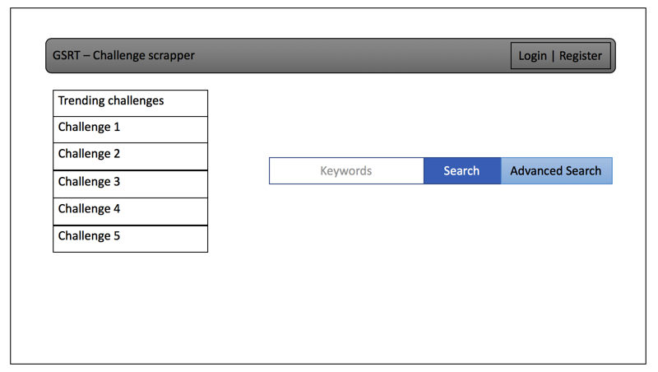

From Report #1 is a mock-up of a description page for an individual challenge:

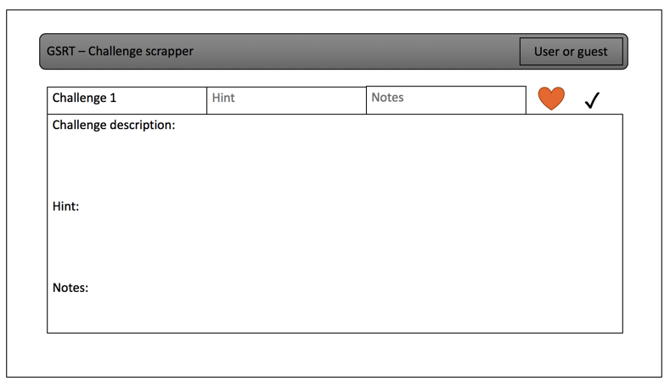

Front-End Tests

**Display Tests**

Test case 1: Display View

Function Tested: displayView()

Success/fail: an html page containing the details of a clicked challenge

Expected Result: A detailed page contain all relevant challenge information is displayed

Expected Failure: No page is displayed

Test case 2: Display Challenge

Function Tested: displayChallenge()

Success/fail: a html page contains a list of challenges meeting the criteria is generated

Expected Success: a list is correctly displayed of relevant challenges

Expected Failure: No new page is displayed

Test Case 3: Display Error

Function Tested: DisplayError(error)

Success/fail: a detailed error message is displayed on screen

Expected Success: an error message that contains info about the error is displayed

Expected Failure: a generic error message of “something went wrong” is displayed

**Search Tests**

Test case 4: build search

Function Tested: buildSearch()

Success/fail: a successful and correct searchParameters has been built,

Expected Success: An accurate searchParameters is built from user generated parameters

Expected Fail: A default searchParameters is built from default values

Test case 5: send query

Function Tested: sendQuery()

Success/fail: a successful query has been passed to DBconection

Expected Success: a query is sent down through DBconnections to the database

Expected Failure: a query is unable to be sent, and the user is notified that it failed to search

**Format Data Tests**

Test Case 6: Format list

Function Tested: formatList(listData)

Success/fail: correct data is provided, and a list is built

Expected Success: a successful list is built and sent to the lister

Expected Failure: a list was unable to be built and an error is sent to lister

Test Case 7

Function Tested: formatChallenge(challengeData)

Success/fail: correct data is provided and a challenge has been built

Expected Success: an accurate challenge object is sent to viewer

Expected Failure: a error is sent to challenge viewer

Test Case 8

Function Tested: buildPage()

Success/fail: a page has been correctly built that can be displayed

Expected Success: a page has been built and passed into the interface to display to user

Expected Failure: an error message is displayed to user

Back-End Tests

The back end has numerous functions that are important but relatively straight forward when using the appropriate built-in PHP libraries. Retrieving HTML from an external website, parsing out useful information from the HTML, getting information from the database, and uploading to the database. These can be expounded on later, but for now they will be skipped so that we can deal with the heart of the back-end tests: incomplete database states.

Test Case 1: Inititial Search

This case occurs when an external site has never been collected from before. A success means that links to every single challenge is collected and uploaded. A failure occurs if less than all challenges are uploaded.

This will be the status immediately after an upload has occurred and will remain that way until the external site posts new challenges. Success occurs if no uploads are made. Failure occurs if any uploads are made.

Test Case 3: New links on newest index

This will be the most common state that our system encounters. Our system has already uploaded some challenges, but new challenges have been posted. A success occurs when all new challenges are uploaded. Failure occurs if not all new challenges are uploaded or if old challenges are re-uploaded.

Test Case 4: Newest links on older index

**This is a modified version of Case 1. If a multi-index site has not been visited for a long time, the number of uncollected challenges may exceed the number of challenges/index on the external site. Our system must collect all new challenges on every index page. A success occurs when all new challenges are uploaded. Failure occurs if not all new challenges are uploaded or if old challenges are re-uploaded.**

**7. Project Management and Plan of Work**

1. Merging the Contributions from Individual Team Members  
   Compiling the final copy of the report from everyone’s work, ensuring consistency, uniform formatting and appearance.  
     
   Currently Matt is merging the contributions from Team Members.  
     
   Describe what issues were encountered and how they were tackled.
2. Project Coordination and Progress Report  
   What use cases have been implemented?   
   What is already functional, what is currently being tackled?  
   List and describe other relevant [project management](http://www.ece.rutgers.edu/~marsic/Teaching/SE/projects.html" \l "TEAMS) activities.
3. Plan of Work  
   List the projected milestones and dates by which you plan to accomplish them. Preferably, you should use [Gantt charts](http://www.ganttchart.com/) for planning and scheduling your project.

This Gantt chart shows the milestones required in order to meet a November 1st deadline. This will allow for several days to record demo 1. The database, web scraper, and User Interface can all be created independently. The uploader is dependent on the Web scraper. Details are dependent on results which are dependent on search, which is dependent on both the user interface and the uploader.

Additional features and requirements, most notably related to user accounts, will be implemented for demo 2. As demo 2 approaches, updates will be made to the Gantt chart and plan of work.

1. Breakdown of Responsibilities
   * List the names of modules and classes that each team member is currently responsible for developing, coding, and testing
     + Matthew Griffin: Will finish back-end documentation and implementation.
     + Martin Tiernan: Will continue working on front-end and documentation.
     + Brenton Dube: Just joined project. Will study existing documentation to get up to speed on project direction. Will create basic non-functional UI for front end.
   * Who will coordinate the integration?
   * Who will perform and integration testing? (The assumption is that the unit testing will be done for each unit by the student who developed that unit.)